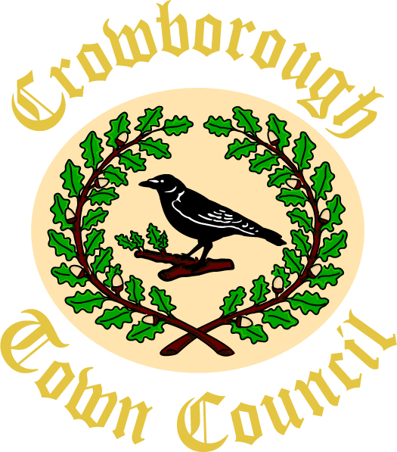

CROWBOROUGH TOWN COUNCIL

Job Description

Post Title: RESPONSIBLE FINANCE OFFICER
Responsible to: Town Clerk
Salary Scale: SCP 29-38 £32,029 - £40,760

Hours of Work: 15 hours per week + evening meetings approx. 6 pa.

RESPONSIBLE FINANCE OFFICER

Parish/Town Councils are required by Section 151 of the Local Government Act 1972 to appoint a Responsible Finance Officer to manage their financial affairs.

Job Purpose:

- To report fully, at regular intervals, in accordance with proper practices, on the Council’s financial position.
- To be accountable for the effective management of the Council’s finances and financial records.

Key Responsibilities:

- Make sure that the Council is accountable and complies with legislation.
- Review and update financial regulations annually and monitor compliance.
- Manage the risks involved in raising and spending public money and keep a financial risk register.
- Provide the Council and committees with financial information to help members make sound budget decisions.
- Prepare the draft budget in conjunction with the Town Clerk and committee chairman.
- Complete the Precept request.
- Keep financial records; balancing and reconciling with bank statements on a monthly basis.
- Manage all financial procedures including insurance and VAT, ensuring quarterly VAT returns are filed on time.
- Provide month end reports to all councillors.
- Ensure there are sufficient funds available at any given time to enable commitments to be met.
- Prepare the end-of-year accounts and, in liaison with the Town Clerk and the internal auditor, prepare the annual return and accounts for the Council.
- Sign the statement of accounts on the annual return.
- Make the records available to the external and internal auditors.
- Advise the council regarding investment funds.
- Monitor and update the Council’s financial policies.
- Manage and keep the Council’s asset register up to date.
- Attend the Finance and General Purposes committee meetings.
- Prepare agenda reports for Committees and deal with any questions arising.
- To prepare payroll information for the Payroll Company to process.
- Manage pensions and the automatic enrolment requirements.
- Manage the Mayor’s charity account.

General Responsibilities:
- To recognise and be aware of the requirements of the Health and Safety at Work Act as well as Fire and Safety regulations and ensure that these are observed.
- To undertake relevant training as and when identified.
- To undertake such other duties as may be reasonably required by the Council.

