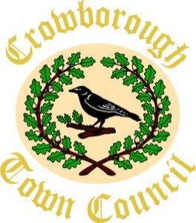
RESPONSIBLE FINANCE OFFICER
Person Specification

 | ESSENTIAL | DESIRABLE
Qualifications | - Relevant accounting qualification, minimum Part qualified Accountant or 3 years’ experience as RFO or other senior accountancy experience. | - Educated to degree level or equivalent  - CiLCA
Knowledge & Skills | - Good numeracy and ability to understand financial data  - Budget management and planning  - Ability to prioritise and plan workload effectively  - IT skills. Minimum requirement – Word, Excel, Outlook  - Excellent written and verbal communication  - Ability to interpret financial data | - Working knowledge of local government  - Knowledge of RBS financial package
Behaviours & Characteristics | - A ‘service driven’ and ‘can do’ attitude  - Excellent customer service focus and interpersonal skills  - A team player, service-oriented, supportive, self-motivated, flexible and able to demonstrate commitment
Work Experience | - Minimum two years accounting experience  - Financial management, including budgetary control and planning for budgets in excess of £400,000  - Experience of end-of-year accounting  - Experience of internal and external audit preparation | - Minimum of two years’ experience in local government  - Minimum of two years’ experience of preparing payroll  - Experience of clerking committees.

