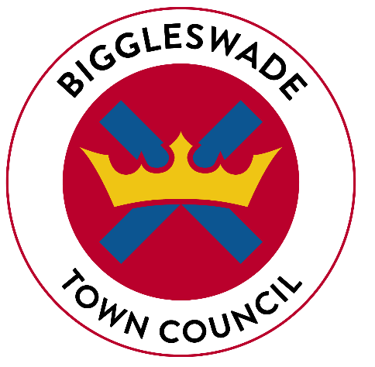
BIGGLESWADE TOWN COUNCIL

APPLICATION FOR EMPLOYMENT

APPLICATION FOR APPOINTMENT AS: DEPUTY PUBLIC REALM MANAGER

CLOSING DATE: FRIDAY 26th FEBRUARY 2021, 5PM

FULL NAME _______________________________  (or initials and last name if preferred)  ADDRESS _________________________________________  _________________________________________  __________________POST CODE | EM EMAIL ADDRESS: | DO YOU WISH TO BE REFERRED TO AS:  MR / MRS / MISS / OTHER?
 | TELEPHONE: HOME | TELEPHONE: WORK PLACE
 | MOBILE NO: | PLEASE INDICATE PREFERRED METHOD OF CONTACT

PRESENT / LAST APPOINTMENT

Name and Address of Employer | Post held | Salary & Other Benefits (if any)
 | Date of Appointment | Length of Notice
Brief Summary Of Duties And Responsibilities

Are you currently in Employment YES / NO

If no please specify date when last appointment ended.

SECONDARY EDUCATION & QUALIFICATIONS

Name of Education Establishment | From | To | Qualifications Gained

FURTHER / HIGHER EDUCATION

Name of Education Establishment | From | To | Qualification(s) Gained
Membership of Professional Bodies | M/Ship Grade | Date | Was membership gained by examination

PREVIOUS APPOINTMENTS HELD (most recent first)
Only go back ten years unless previous experience is particularly relevant to the post.

Employer | From  Mth/Yr | To  Mth/Yr | Position Held | - Salary on Leaving  - Reason for Leaving

DETAILS OF RELEVANT EXPERIENCE AND OTHER SUPPORTING INFORMATION

Please make full use of this page to provide further information in support of your application

INTERESTS, LEISURE ACTIVITIES ETC.

Do you hold a current, full driving licence? Yes / No
Do you own a car? Yes / No

REFERENCES

Please give two referees (not relatives) including your current / last employer:

Name & Address:  Email address:  Telephone No:  Occupation:  Contact prior to interview Yes / No | Name & Address:  Email address:  Telephone No:  Occupation:  Contact prior to interview Yes / No
Are you to your knowledge related to any Council member or Senior Officer of the Council? Yes / No

If yes, please give details:
Where did you see this post advertised:

Equality Act 2010

The Equality Act 2010 protects disabled people - including those with long term health conditions, learning disabilities and so called "hidden" disabilities such as dyslexia. If you tell us that you have a disability we can make reasonable adjustments to ensure that any selection processes - including the interview - are fair and equitable.
* Do you consider yourself to have a disability?

◻ Yes ◻ No ◻ I do not wish to disclose this information

If you have a disability, do you wish to be considered under the guaranteed interview scheme if you meet the minimum criteria as specified in the person specification?

◻ Yes ◻ No

I DECLARE THAT THIS INFORMATION IS CORRECT TO THE BEST OF MY KNOWLEDGE, THAT I HAVE NOT CANVASSED AND WILL NOT CANVASS DIRECTLY OR INDIRECTLY IN CONNECTION WITH THIS APPLICATION.

SIGNED……………………………………………. DATE……………………………………….
Data Protection Act 2018
Please note that your personal details supplied on this form will be held and/or computerised by Biggleswade Town Council for the purpose of this application. The information collected may be disclosed to officers and members of the Council and its’ partners involved in this application. Summarised information from the forms may be published, but no individual details will be disclosed under these circumstances. Your personal details will be safeguarded and will not be divulged to any other individuals or organisations for any other purposes. If you do not wish to have your personal details retained for the purposes given, please contact enquires@biggleswadetowncouncil.gov.uk who will arrange for their removal and deletion. We will only be able to locate your data for removal if you have provided us with a personal identifier, such as your email address.

Please return to:

enquiries@biggleswadetowncouncil.gov.uk

Or

Biggleswade Town Council
The Old Courthouse
4 Saffron Road
Biggleswade
Beds
SG18 8DL

