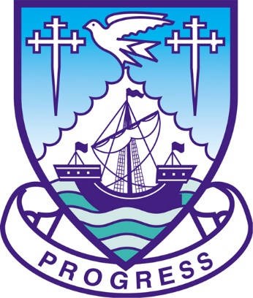

Littlehampton Town Council

Appointment of

Deputy Town Clerk & Responsible Financial Officer

Recruitment Information Pack

June 2021
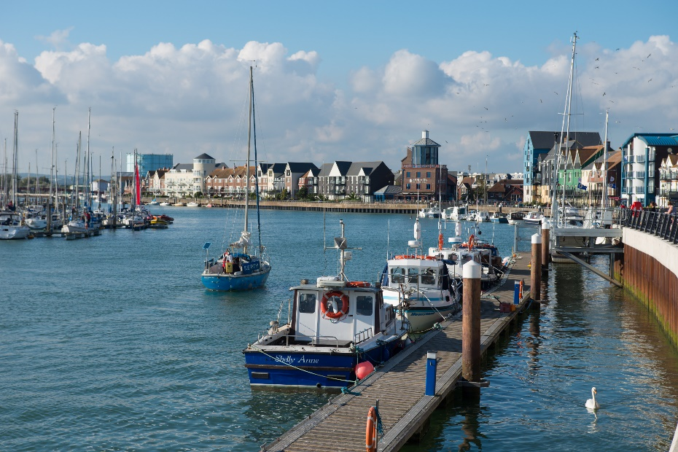

Littlehampton Town Council

Recruitment Information Pack Contents

1 | Littlehampton Town Council
2 | Advertisement
3 | Job Description
4 | Person Specification

Littlehampton Town Council

The Town of Littlehampton

The town of Littlehampton lies on the south coast between Bognor Regis to the west and Worthing to the east. It has a resident population of approximately 30,000, which as a result of new development, is likely to increase significantly over the next few years. With two award winning beaches, the beautiful river Arun and river walkway, a large seafront green and in close proximity to the South Downs National Park, tourism is a key part of the local economy. The Town Council, working in partnership with the local community, deliver a diverse range of events and activities throughout the year for residents and visitors which maximise these wonderful, natural facilities.

The town centre is small, but busy with an active Trader’s Partnership which is supported by the Town Council. The secondary centre of Wick also has an active thriving community. Although the town is growing it retains a very strong community identity.

The town has benefitted from an active regeneration programme over the years and although pockets of deprivation still remain, Littlehampton is very much on the up, with some iconic art projects that have received worldwide acclaim and significant infrastructure improvements to be delivered through new development.

The Council

Littlehampton Town Council was created in 1974 following the reorganisation of local government and the disbanding of Littlehampton Urban District Council. It is, in financial terms, the largest parish in West Sussex with a precept of over £1 million.

The residents are currently represented by 15 Councillors (covering six wards) each elected for a term of four years, the last election being in 2019. Each year the Council elects from amongst its members the Town Mayor and Deputy Town Mayor. The current political composition of the Council is 5 Liberal Democrats, 3 Labour, 2 Conservatives, 2 Littlehampton Independent Group and 3 others.

The Council’s Mission Statement is:

‘The Members of Littlehampton Town Council, are committed to providing, maintaining and developing services and local initiatives, which will improve the quality of life of the residents of Littlehampton & Wick’.

We are governed by a series of policies which guide us through our strategic work.

Principal Aims

The Town Council will serve the community by:
- Providing and maintaining a range of public services and seeking to develop effectively other services, either directly or by supporting local organisations and other providers.
- Actively pursuing their representative role.

Beliefs and Values

In carrying out the Council’s aims, the Town Council will be guided by the following principles:
- Delivering services to the highest quality in terms of efficiency, effectiveness and value for money.
- Promoting a culture of continuous improvement.
- Conducting business openly, impartially and democratically and where necessary consulting widely with parishioners, all sections of the community and interested parties.
- Complying with the National Code of Local Government Conduct and the Nolan Principles in public life.
- Obtaining from contractors and partners the best possible service value whether from statutory bodies or subcontracted services.
- Acting in the best interests of local people in making representations to and entering into partnerships with:
  - Arun District and West Sussex County Councils
  - Outside Agencies
  - Central Government
  - Other appropriate private, public or voluntary sector groups
- Adopting a positive approach to resolving issues.
- Encouraging all staff to reach their full potential.

Functions of the Town Council

The only statutory function provided by the Town Council is ownership and management of six allotment sites. With two new, large housing developments currently under construction the number of allotments sites will increase over the next couple of years.

However, the Town Council also:

- Manages Littlehampton Museum which is based on the ground floor of the Town Council offices at the Manor House.
- Employs a direct workforce of four permanent staff, the Amenity Team, who are responsible for the general maintenance of the Council’s buildings and facilities assisted by casual staff in periods of high workload. The ‘A Team’ also take care of the street scene and graffiti removal.
- Owns and manages the Manor House (Town Council offices and a licenced wedding venue) and Southfields Community Centre. These are supported by caretaking services directly employed by the Council. It is also anticipated that the Town Council will own and manage another two community centres which will be funded through the sale of Town Council land and Section 106 funding relating to new development. Work has already begun design proposals for one of these community centres in Wick.
- Owns and manages Rosemead Park which has recently benefitted from a brand new playground.
- Lists amongst its assets a wide range of street furniture including an art project ‘Stage by the Sea’ which is situated on the seafront, the Beacon which is also on the seafront and the War Memorial. In addition, the Town Council supplies and maintains trees and floral displays and is currently investigating further art installations.
- Frequently works in Partnership with other authorities and local organisations in particular Arun District Council, whose Civic Centre is based in Littlehampton and West Sussex County Council who are based in Chichester. This is particularly highlighted by the joint work on the major housing developments in the town. The development of the Littlehampton Neighbourhood Plan strengthened the Town Council’s links with the community and there are many active voluntary and resident groups with whom the Council regularly consults.
- Delivers a joint youth service with Arun Church through Arun Youth Projects.
- Has an active grant programme, providing financial support to many community groups in the town.
- Supports local tourism, arts, sports, publicity campaigns to raise the profile of the town and delivers an annual events programme. The Town Council also produces and delivers a quarterly newsletter to almost every household as well as an e-newsletter, keeping residents informed about what is happening in their community.

Staffing Structure

The Council’s staff implement the Council’s policies and deliver the functions and services as set out above. A copy of our staff structure can be found on our website:
https://cdn.littlehampton-tc.gov.uk/public/2021-06/Staff%20Structure%20-%20June%202021.pdf

Meetings

All the council meetings are held in the Millennium Chamber of the Manor House and normally commence at 6.30pm as set at the beginning of each Council year by each Committee. The Committee calendar for 2021 can be found on our website: https://www.littlehampton-tc.gov.uk/committee-meetings

Manor House, Church Street, Littlehampton, West Sussex BN17 5EW
Telephone: 01903 732063
Email: ltc@littlehampton-tc.gov.uk
www.littlehampton-tc.gov.uk

Deputy Town Clerk and Responsible Financial Officer
(based at the Manor House)

37 hours per week
LC3 Spinal Column Point 37-41 £40,876 - £44,863

Littlehampton Town Council is the parish authority for the Town of Littlehampton. The Council provides a range of services and facilities including allotments, the Museum, Rosemead Park, the Grant Aid Scheme and Southfields Community Centre. There are exciting new developments ahead too, which include a further two community centres for the Town Council.

The Council is seeking a highly motivated professional to join our friendly team working to improve the quality of life for the residents of Littlehampton and Wick. If you thrive in a busy work environment and enjoy variety in your work, then this could be the ideal job for you.

The post holder will support the Town Clerk in ensuring the smooth running of the Financial Administration and Corporate Governance of the Council and oversee its central administration and facilities management.

With a Precept of over £1 million and budgets of over £1 million for new projects this is an exciting opportunity for someone experienced in finance. Preferably with a recognised accounting qualification, along with experience of accounting and administrative practice, budget preparation and management, you will be able to effectively manage the Council’s finances, ensuring compliance in line with the Accounts and Audit Regulations. Experience of maintaining a small monthly payroll is also required.

Excellent communication and interpersonal skills along with experience in a wide range of personnel processes are essential to take the lead on day-to-day human resources management and to directly manage the Administration Team and the Amenity Team.

Other duties include deputising for the Clerk, preparing reports for Committees and attending occasional evening meetings. The post holder will also lead on ICT, insurance, safety, and security.

A recruitment information pack and application form are available to download from our website at www.littlehampton-tc.gov.uk or contact us on the details above for a pack. For further information about this opportunity contact Peter Herbert, Town Clerk.

Closing Date: Monday 5th July 2021 at 9.00am
First Interview Date: Thursday 8th July 2021
Potential Second Interview Date: Thursday 15th July 2021

Only completed application forms will be considered for this position and only applicants invited for interview will be contacted.

The Town Council is an equal opportunities employer.
Benefits include 27 days annual leave, bank holidays and 3 statutory days at Christmas as well as membership of the Local Government Pension Scheme.

Job Description

DEPARTMENT: | Finance and Resources
LOCATION: | Littlehampton, Manor House
JOB TITLE: | Deputy Town Clerk and Responsible Financial Officer
GRADE: | LC3 Spinal Column Point 37-41
RESPONSIBLE TO: | Town Clerk
RESPONSBILE FOR: | PA to Town Clerk, Amenity Team Co-Ordinator, Finance Assistant

MAIN PURPOSE OF THE ROLE:

As the Town Council’s Responsible Financial Officer manage and administer the Council’s financial affairs in accordance with relevant legislation, regulations, policies, and guidance.

To be responsible for the management of the Town Council’s support functions including the Administration Team, Amenity Team, ICT and Human Resources.

To support the Town Clerk in the exercise of their duties as required, and, in the absence of the Town Clerk, assist in the legal and prescribed duties of the Proper Officer in accordance with the Scheme of Delegation to Officers.

Key Tasks

- Manage and administer the Council’s financial affairs in accordance with the Accounts and Audit Regulations 2015 and subsequent legislation, ensuring safe and efficient arrangements are in place to safeguard public money.

- To oversee and manage all financial functions of the Council including but not limited to: Fiscal Governance; Accounting Records and Financial Control; Annual Return and Accounting Statements; Budgets and Financial Monitoring/Predictions; Financial Project Feasibility Studies; Insurance; Risk Management of Financial and Business risks; Internal Controls; External and Internal Audits; Payroll, PAYE, NIC and Pensions; Borrowing; VAT; Investments; Assets.

- To devise, review and ensure adherence to the Council’s financial strategy, regulations, policies and procedures, and advise the Council in relation to these, to include investment, cash flow and bank transfers.

- To maintain contracts and ensure compliance in line with the Council’s Standing Orders, Financial Regulations and Procurement Policy

- In conjunction with the Town Clerk, prepare and advise on the annual estimates of income and expenditure for revenue services (Revenue Budget) and advise on the Capital Programme Budget. Subsequently, provide the Committees of the Council with a regular monitoring statement.

- To manage the Town Council’s Administration Team, providing effective administrative support for the organisation and ensuring the office is always staffed when the Council is open to the public. Ensure proper and accurate records are maintained, and that all procedures relating to best office management practices are followed, through the PA to the Town Clerk.

- To manage the Town Council’s Amenity Team overseeing the work schedules for maintenance and repair of civic buildings and facilities, to include community centres, recreation grounds, open spaces, street furniture, allotments and removal of graffiti, fly-tipping and fly-posting, through the Amenity Team Co-Ordinator.

- To maintain detailed health and safety and fire protection and security systems within the Council and to supervise health and safety matters as they relate to the offices.

- To advise the Town Clerk on all aspects of human resources and lead on day-to-day matters. To ensure appropriate confidential personnel records are held and maintained. To co-ordinate training and development across the organisation.

- To assist all other Heads of Service in the exercising of their duties, providing cover as necessary in their absence and supporting them to manage staff and monitor budgets for which they are responsible.

- To recruit, manage, support and motivate staff through regular supervision, ongoing training and development.

- To oversee ICT matters and lead on related day-to-day matters.

- To manage relevant pages on the Town Council’s website with an efficient schedule for content management, providing timely access to required information in accordance with the Transparency Code 2015.

- To assist the Town Clerk in meeting the legal, financial, governance, and administrative obligations of the Council, providing advice and information as requested by the Town Clerk and the Councillors.

- To attend Committees (and Clerk as required) and meetings as agreed with the Town Clerk, and to advise the Council in matters relating to Committees, specifically Policy and Finance and Governance and Audit.

- To confidently use Microsoft Office and a variety of software packages to undertake the role efficiently.

- To be a keyholder for all Town Council properties and provide a limited call out service as required.

- To comply with the Town Council’s Health & Safety Policy at all times.

- Apply consistently the principles of Equal Opportunities, as embodied in the Town Council’s policies and practices throughout the duties outlined.

- To undertake available training opportunities identified through appraisal and supervision and show a commitment to continuous development, to maximise your potential and ensure the efficient and effective delivery of Town Council services.

- To undertake any other tasks commensurate with the grading of the post, as required by the manager/supervisor or the Town Clerk, ensuring that all duties undertaken are done so in accordance with Council policies, practices, procedures and standards.

This job description sets out the duties of the post at the time when it was drawn up. Such duties may vary from time to time without changing the general character of the duties or the level of responsibility entailed. Such variations are a common occurrence and cannot of themselves justify a reconsideration of the grading of the post.

Notes:

This post is politically restricted under the terms of the Local Government and Housing Act 1989.

Person Specification

Post Title: Deputy Town Clerk and Responsible Financial Officer
Location: Littlehampton
Grade: LC3 Spinal Column Point 37-41

 | Essential Criteria | Desirable Criteria | Method of Assessment/  Source of Information
Key Skills & Abilities | - Excellent ICT skills, able to use Microsoft Office software and other software packages with confidence  - Proficient with the Internet, Email and Social Media  - Exceptional ability to communicate effectively both verbally and in writing to a range of audiences including councillors, voluntary and local community groups, third party contractors and colleagues  - Report writing skills including the presentation of financial information  - Proven ability to manage, supervise and work as part of a small team  - Proven ability to effectively organise own workload and meet tight deadlines, managing changing and conflicting demands  - Ability to use own initiative and work independently  - Ability to undertake a diverse workload  - Ability to make decisions that fall within level of responsibility  - Ability to respond positively and proactively to complex and unexpected problems and situations  - Professionalism in representing the Council to Members, colleagues, other organisations and the public  - Ability to organise, conduct, chair and speak at meetings  - Negotiation skills  - Good presentation skills  - Ability to project manage work  - Excellent numeracy and literacy skills |  | Application form/Interview/  Reference
Education &  Qualifications | - GCSE Maths and English (Grade 5, previously C and above) or equivalent  - Have or working towards a recognised accounting qualification or other qualification with accounting as a demonstrable element | - Part/fully qualified ACCA, CIPFA, ICA or CIMA  - CiLCA  - Business/ Management/HR qualification | Application form
Knowledge | - Knowledge in Human Resources Management  - Knowledge of Town/Parish Council sector  - Working knowledge of Microsoft Word, Excel, Power Point, Outlook and Internet Explorer  - Knowledge of organisational IT needs  - Awareness of health and safety and risk management and its application  - Awareness of equal opportunities, Equality Act 2010 and the protection of children and vulnerable persons | - Knowledge of Democratic Services  - Knowledge of Littlehampton  - Knowledge of the services provided by Littlehampton Town Council  - Understanding of the key issues impacting local government, especially town/parish councils  - Understanding of the issues facing Littlehampton Town Council | Application form/Interview
Experience | - Experience of a wide range of personnel processes and leading an organisations HR function  - Experience of staff supervision/management and motivating a cross-functional team to ensure results are delivered  - Experience of working with accounts and budgets at a high level  - Experience of accounting and administrative practice including running a payroll system  - Of Microsoft Office, social media, databases and the Internet, including accounting software  - Experience of liaising and working at a senior level with other organisations  - Providing customer focussed services to the community  - Dealing with a wide range of correspondence and enquiries  - A busy environment/office | - Experience of working in a political, public sector environment  - Experience of working for or with a Town/Parish Council  - Experience of overseeing an organisation’s insurance needs  - Experience of drawing up and monitoring contracts and contractors  - Experience of working with Sage 50 Payroll  - Experience of working with Rialtas | Application form/Interview/  Reference
Personal Attributes | - Excellent interpersonal skills  - Willingness to take on a range of tasks as required  - Customer focused  - Flexible and self-motivated approach to work  - A positive approach to problem solving  - Diplomatic and assertive  - Honesty and reliability  - Attention to detail | - A demonstrable interest in the town of Littlehampton either past or present | Application form/Interview
Other | - Ability and willingness to work evenings and occasionally at weekends  - Ability to undertake manual handling tasks  - Flexible to change working hours when needed
Date (drawn up): 09/06/2021
Reference of Officer(s) drawing up Job Description and Person Specifications: PH, LC

