CAM PARISH COUNCIL,
4 Noel Lee Way, Cam, Glos GL11 5PS
www.camparishcouncil.gov.uk

Dear Applicant
Re: Project Officer
Please find enclosed in this pack:
Job Description
Person Specification
Job Advert
Short Application Form
Please complete the short application form and provide a CV detailing your experience and why you have applied for the post. Applications can be made by post or via email. It is not necessary to send a paper application as well as an email. All applications will be acknowledged by email.
Closing date for application is 16 March 2022.
Interviews will be held in the week beginning 21 March 2022.
If you require any further information, please contact me.

Yours faithfully
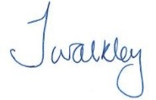
Jenny Walkley
Clerk to Cam Parish Council

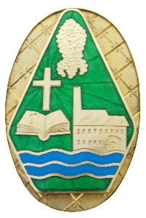
PROJECT OFFICER
Salary Range: LC2 Scale) 24-28 SCP. (£28,672-£32,234)
30-37 Hours per week (negotiable), including some evening and weekend requirement
Cam Parish Council is seeking to recruit an enthusiastic and effective Project Officer to facilitate and drive forward the visions of the parish council, commencing April 2022 (negotiable for right candidate).
Cam is a large parish in the Stroud District, with a population more than 8,500 with 16 serving Councillors and an annual budget of approximately £350,000. It is a proactive council committed to maintaining and expanding community assets and services.

Applicants should be highly motivated and well organised, able to demonstrate a good record of achievement in a similar role, have a good understanding of financial matters and be able to work flexibly and independently as well as part of a team. Good oral, written communication, IT and strong inter-personal skills are essential.

Benefits of working for us:
- As an employer, the Council are committed to ensuring staff have a healthy workplace and have a strong commitment to the health and wellbeing of our staff.
- Entry into the LGPS pension scheme
- 22 days holiday per year rising to 25 days after 5 years’ service + bank holidays + 2 extra days over Christmas period
Application packs may also be downloaded from our website at www.camparishcouncil.gov.uk
Letters of application and completed application forms may be sent by email or posted to:
Mrs Jenny Walkley,
Cam Parish Council
4 Noel Lee Way
Cam
Glos
GL11 5PS

The closing date for applications is Thursday 16th March 2022.
Initial interviews will be conducted week commencing Monday 21st March.

