

Job Description

Project Officer, Corporate Services (Job Share)
Climate, Environment, Land and Property

Salary and Scale Point: £24,012 (SCP16) - £26,511 (SCP 21)

Responsible to: Chief Executive Officer

Main Purpose: The main purpose of the Project Officer post is to provide a lead role in supporting the delivery of the Council’s thematic Corporate Strategy alongside the preparation and implementation of a long-term strategy focused on the organisation and core services through partnership, policy and projects.

The role will focus mainly on our climate, environment, and land and property priorities; as we continue to respond to COVID related needs and build back a stronger and sustainable community.

As well as being a project role, tasks could include the preparation of agendas, reports and minutes; as well as the drafting of vision statements and preparing masterplans for our open spaces and scheduled ancient monuments.

Key Points of Contact: Chief Executive Officer
Senior Management Team
Lead Officers
Lead Members
Project Officer (Job Share)
Student Intern (Part-Time)
Chair of Council
Chair of the Climate Change Advisory Group
Internal and External Stakeholders

Key Skills and Attributes: A wide range of project skills and attributes are needed for the successful support and delivery of the Corporate Strategy:

Management Information
Research and Report Writing
Finance and Administration
Information Technology
Internal and External Communication and Engagement
Co-ordination of task and finish projects
Initiative and Innovation
Problem Solving
Shaping and Planning Tasks
Thematic Overview (an outline of key projects and tasks):

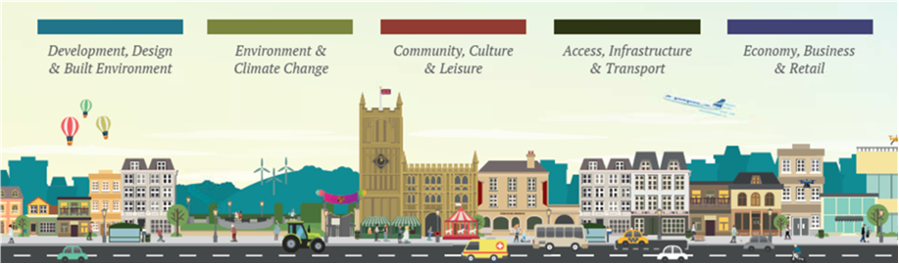

Environment and Climate Change

Sluice gate operation and flood response.

Cricklade Street, Riverside Walk and Brewery Court improvements.

Town Centre Regeneration.

To audit and benchmark the carbon footprint of Cirencester Town Council.

Encourage the co-operation of local organisations to be more ecologically sustainable.

Green Spaces Strategy review and update.

Amphitheatre Masterplan review and update.

Preparation of a vision document and masterplan for the Abbey Grounds.

Community, Culture and Leisure

Review of ward-based community group arrangements and engagement.

Liaising with local Friends of Groups.

Community resilience and emergency response.

Sport and Recreation.

Access, Infrastructure and Transport

Creating a local multi modal mobile hub.

Responding to unmet transport need.

Encouraging behavioural change and modal shift.

Develop and improve pedestrian links and cycle routes.

Development, Design and Built Environment

Influence developers in responding to climate emergency and sustainable building.

Working Hours:

Up to 22 hours per week Monday to Friday

Cirencester Town Council operates a flexible working policy and the working hours can be undertaken; whilst working from home will be considered this post will require the post holder to be office based on a regular basis.

Other:

The Council operates in a flexible way where all staff try to help each other as such from time to time there may be a requirement to support other service areas, including outside of normal office hours. The Town Council also provides management support to the Bingham Library Trust and the Cirencester Community Development Trust and from time to time tasks, commensurate with the post, may be required.

To be aware of and give consideration, within the role and remit of the post, to issues relating to relating to equality, diversity and climate emergency.


Bingham House, No. 1 Dyer Street, Cirencester, Gloucestershire, GL7 2PP
T: (01285) 655646/F: (01285) 643843/E: info@cirencester.gov.uk/W: www.cirencester.gov.uk

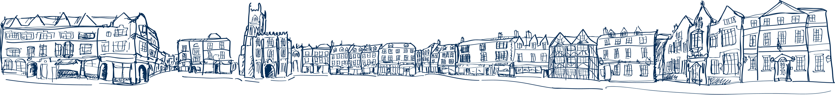

PERSON SPECIFICATION

Requirements | Essential or Desirable | Method of Assessment
Qualifications:
Degree or Equivalent | Essential | Application
Project Management | Desirable | Application
Climate and Environment | Desirable | Application
Horticulture/Archaeology | Desirable | Application
Experience:
Similar Role | Essential | Application/Interview
Administration | Essential | Application/Interview
Climate and Environment Projects | Essential | Application/Interview
Co-ordinating Task and Finish Projects | Essential | Application/Interview
Project Management | Desirable | Application/Interview
Land Management | Desirable | Application/Interview
Community Engagement | Desirable | Application/Interview
Skills and Attributes:
Initiative and Innovation | Desirable | Application/Interview
Problem Solving | Desirable | Application/Interview
Shaping and Planning Tasks | Desirable | Application/Interview
Self-Motivated and Proactive | Desirable | Application/Interview
Prioritising Tasks and Meeting Timelines | Desirable | Application/Interview
Research and Report Writing | Desirable | Application/Interview
Other:
Judgement, Tact and Discretion | Essential | Interview/References
Use of Information Technology and Social Media | Essential | Application/Interview

