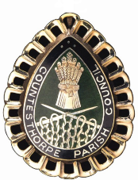
COUNTESTHORPE PARISH COUNCIL
PERSON SPECIFICATION: PARISH COUNCIL MANAGER
Criteria | Essential (E)/  Desirable (D)
Knowledge  Understanding of Microsoft office applications.  Previous experience of Parish Council accounting software/systems  Previous experience in Local Government Administration  A basic knowledge / competence of Health and Safety at Work | E  D  D  E
Skills/Abilities  Excellent verbal communication skills  Ability to work well under pressure  Ability to lead and work as part of a team of 10  Ability to work on own initiative  Ability to work with committees | E  E  E  E  D
Experience  Experience of working with the general public and a good telephone manner  Experience of being a Financial Officer  Cash Handling | E  D  E
Qualifications/Training  Certificate in Local Council Administration (CILCA)  or be prepared to work towards the CILCA qualification | D  E
Other  Willingness to work unsociable hours with a flexible attitude | E

