HEAD OF CULTURAL & ECONOMIC SERVICES
INFORMATION FOR APPLICANTS

Welcome from the Town Clerk

Town Clerk
Leighton-Linslade Town Council
The White House
Hockliffe Street
Leighton Buzzard
Bedfordshire
LU7 1HD

May 2022

Dear Colleague
Welcome to Leighton-Linslade Town Council | A community to be proud of
Thank you for your interest in becoming our new Head of Cultural & Economic Services. I am thrilled to have the opportunity to share with you our plans for our community and tell you a little more about how you can make a difference.
We are less than an hour from London, bordering the Chilterns Area of Outstanding Natural Beauty. We have a thriving town centre and a 1000 year-old market as well as many independent shops, cafés, bars and restaurants. Our proximity to the Grand Union Canal and the River Ouzel gives us a waterside feel that enhances the environment. Our population is 45,000 and growing, and along with it our role as a Town Council.
We are at the heart of our community and are one of the largest Town Councils in the country, recognised as a “Super Council” by government and our national association, NALC. Our reach and contribution in the town extends far beyond the work undertaken by many councils. Working in partnership with Central Bedfordshire Council, we seek to find ways where we can improve our town and contribute to the lives of our residents and communities. As Head of Cultural & Economic Services, you can take the lead in many of these initiatives, from markets and events that create commercial opportunity, to community projects that help our residents feel safe and stay connected.
A decade ago we took on the Charter for Leighton-Buzzard Market. This historic and modern feature of our town was first mentioned in the Domesday Book and is more relevant now than ever, creating opportunity and cohesion and winning awards along the way. In this role, you will lead our market service, continuing our tradition of excellence, but bringing your own fresh thinking that takes forward the market’s offer. Our town is bursting with independent retailers, and you will be a key partner in supporting these businesses to succeed, by helping create the conditions where they can thrive.
We have a busy programme of events which are free for residents to attend and are an important part of the life of Leighton-Linslade. The development and delivery of these events would be led by your team. We also provide grant funding to a range of local initiatives, including Citizens Advice, various Watch Schemes and other projects that enhance community safety. Our Teenage Advice and Information Centre (TACTIC) is a wonderful resource where young people can meet, volunteer, spend leisure time and stay connected.
The local government landscape is a complex one for residents to navigate to access services. As a local point of contact and a reliable, constant and visible presence in the town, we will always seek ways to work with our partners to raise awareness of issues and help develop solutions. Our role here is to understand and champion the views of our residents, for example in ensuring that our population growth is matched with appropriate, environmentally sustainable infrastructure.
From our market to our retail and business sector, from our community initiatives to our events and cultural programmes, this is a role of real breadth and will give you the chance to really make a difference to our town and community.
I hope this introduction has sparked your enthusiasm to apply for this important, challenging, and fun role in our closely knit team. Fit is really important to us, so we look forward to spending time with you, getting to know you better and giving you the chance to see how we can work together for Leighton-Linslade.

Kind regards

Mark Saccoccio
Town Clerk
Leighton-Linslade Town Council
About Us
Overview of Leighton Buzzard and Linslade
Leighton-Linslade is the largest town in the administrative area of Central Bedfordshire Council. Historically, Leighton Buzzard has always been within Bedfordshire, with the area of Linslade transferring from Buckinghamshire in 1965.
The parish has a growing population of 45,000 (37,470 according to the 2011 census with 16,410 dwellings). The population continues to grow as further housing development takes place to the south and east of the town. The unemployment rate in Leighton-Linslade is on a par with the rate in Central Bedfordshire and lower than the England average.
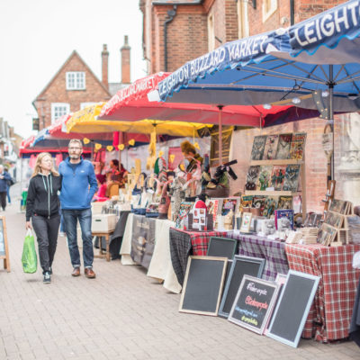

Ideally placed within an hour of London, the town is an ideal location for commuters and a significant proportion of those living in the parish work outside it. The parish contains a number of ancient buildings including All Saints Church and the Market Cross monument.
Surrounded by quarries, the town is famous for its high quality sand. The Narrow Gauge Railway and the Grand Union Canal remain reminders of the industrial links of the past and the key strategic location of the town. Leighton Buzzard has held a market for many hundreds of years and this continues to be held today, every Tuesday and Saturday now under the management of the Town Council.

Overview of Leighton-Linslade Town Council
Leighton-Linslade Town Council came into existence on 1 April 1974 with the powers of a parish council and is responsible for the following areas:

- Parks, play areas, pavilions and open spaces
- Markets
- Allotments at Weston Avenue and Alwins Field
- Cemeteries at Vandyke Road and Old Linslade Road
- Community events and Christmas illuminations
- Teenage Advice and Information Centre (TACTIC)
- Public conveniences (West Street car park)
- Publications e.g. About Town bi-monthly newsletter, annual What’s On leaflet
- Providing grants to local charitable and voluntary groups

The Council comprises 21 elected Councillors who each serve a four-year term of office. There are eight electoral wards in the Parish:

- Barnabas (3 Councillors)
- Brooklands (2 Councillors)
- Grovebury (4 Councillors)
- Leston (1 Councillor)
- Planets (2 Councillors)
- Plantation (3 Councillors)
- Southcott (4 Councillors)
- St Georges (2 Councillors)

Town Councillors are not paid any expenses or allowances, apart from the Town Mayor, who receives a relatively small allowance, and who attends many events throughout the region to represent the town. The Town Mayor also organises a number of events throughout the year to raise funds for charity.
The Town Council has four Standing Committees: Cultural and Economic Services Grounds and Environmental Services Planning and Transport Policy and Finance In addition, there is a joint committee with Central Bedfordshire Council: the Leighton-Linslade Partnership Committee. Council, Committees and Sub-Committee meetings are open to the public, unless there is a special reason for exclusion. Up to a total of fifteen minutes is allowed for representations from members of the public, who may ask questions or make statements relating to items on the meeting agenda.
The Town Council currently employs a team of approximately 45 staff led by the Town Clerk, Mark Saccoccio. The Council is entirely funded by the residents of Leighton-Linslade through what is known as a precept on the council tax charge, and by generating income through services delivered.
Link to staffing structure: Click Here

Job Advertisement
We are one of the country’s largest Town Councils, with a proud tradition of contribution and excellence. We serve the vibrant, historic and welcoming communities of Leighton Buzzard and Linslade in the heart of Bedfordshire. Working together with our Councillors and partners, we are determined to realise our vision, “A Community to be Proud Of.” That means achieving high quality services promoting well-being for everyone. The role of Head of Economic & Cultural Services is your opportunity to help us deliver our vision.
How you will make a difference
Working as part of the Town Council’s management team, and leading a group of highly dedicated staff and volunteers, you will:
- Promote our Town Centre and other places of interest, encouraging take up of local services from our outstanding offer of independent businesses
- Lead the Town Council’s award-winning market function
- Support partnership working with Central Bedfordshire Council and other stakeholders that helps us deliver our vision and improves services for our residents
- Develop, promote and manage events that provide community cohesion, sense of community and brings people into the town
- Manage community activities and council led projects including our Teenage Advice and Information Centre
What we will need from you
We are a small, cohesive team and we are looking for someone who shares our passion to maximise the potential for Leighton-Linslade. This is your opportunity to use your excellent relationship and communication skills, bringing forward new ideas as well as taking forward existing initiatives. We are looking for someone who can fit in well in our friendly, committed and flexible group. Always willing to contribute and add value, you will bring a level of confidence that allows you to hold important meetings to advance critical Town Council issues. We would be interested in speaking to officers from other town councils or local authorities, as well as candidates from aligned parts of the wider public and private sectors. Either way you will bring experience of leading teams, projects and services in partnership settings that deliver great outcomes for people, be they customers, businesses or residents.

Role Profile

JOB DESCRIPTION

JOB TITLE Head of Cultural and Economic Services

RESPONSIBLE TO Town Clerk
RESPONSIBLE FOR Promoting the Town Centre, Managing the Town Council’s Market Function, Support Partnership Working with Central Bedfordshire Council, Managing Town Council Endorsed Events and Reinforcing the Town’s Identity as a Tourist and Retail Destination, Manage Community Activities and Council Led Projects as well as the Teenage Advice and Information Centre (TACTIC) and the production of the bi-monthly “About Town” Magazine.

GRADE 43-47

SALARY £41,591 - £45,648

HOURS 37 hours per week (full-time)

LOCATION The White House, Hockliffe Street, Leighton Buzzard

Job Purpose
Within the limited legal powers available to the parish sector, to work with partners to encourage residents and visitors alike to visit and shop local by frequenting the twice weekly market, specialty markets, regular events and the retail and service functions available within the town centre.
To oversee community-based initiatives including the Town Council led Teenage Advice and Information Centre and other Council Led Projects.
To lead the smooth running of the Cultural and Economic Services Function including management of staff, contracts, budgets and finances.

DUTIES AND RESPONSIBILITES
Management
- To be part of the Town Council Management Team and to contribute to the overall effective management of the Council.
- To provide professional advice and be strategically and operationally responsible for all service/functions of the Cultural and Economic Service.
- To develop and drive performance management improvement within the Service Area.
- To represent the Council on external bodies and forums where considered appropriate.
- Line management of all employees responsible for delivering cultural and economic service functions, including 1:1s, performance appraisals, absence management etc.
Specific
- To work with partners in the management and development of a vibrant and attractive town centre.
- To manage the Cultural and Economic Services Budget and Earmarked Reserves to include budget setting, forecasting, monitoring and spending in accordance with Council policy and procedure.
- To deliver objectives as set out within the Town Council’s 5 Year Plan or as agreed by the Council body.
- To be the lead officer for the Cultural and Economic Services Committee, Partnership Committee and relevant sub-committees by being responsible for the attendance at meetings and preparation of committee reports ensuring that committee report deadlines are met, manage and maintain committee work plans and thereafter ensure committee decisions are enacted in a timely manner (estimated 6 meetings per quarter).
- To be responsible for the on-going management and development of the Town Council’s market function to include the twice weekly market and speciality markets.
- To be responsible for the engagement with local businesses and community where considered appropriate.
- To be responsible for the management of town council led events and activities within the town centre and or its open spaces where considered appropriate.
- To be responsible for procurement, tendering and on-going contract management for all relevant projects and contracts with the service area.
- To be responsible for the on-going delivery of projects associated with the Town Council.
- To be responsible for the on-going delivery of the Teenage Advice and Information Centre function.
- To work with the Highways Authority to seek improvements to town signage and lighting where considered appropriate
- Contribute to the formulation of policy with respect to matters concerning the management of town centre, markets and events.
- To engage with Central Bedfordshire Council to encourage the timely delivery of the Partnership Project List, Project Plans and Joint Initiatives.
- To attract external funding and submit funding bids to support town centre initiatives.
- To be responsible for the content and publication of the bi-monthly “About Town” community newsletter.
- Undertake any other duties of a similar level and responsibility as may be required from time-to-time.

PERSON SPECIFICATION

Attributes | Essential | Desirable
Education and Qualifications | Qualified to degree level in an appropriate field (ideally a business-related discipline) or demonstrate substantial relevant experience.  Sound knowledge of customer relations and customer care practice  Certificate in Local Council Administration (or similar qualification) or willingness to work to its achievement within 12 months of appointment. | Management or supervisory qualification
Skills and Behaviour | Strategic thinker who is able to drive development and use initiative  Highly personable with excellent interpersonal and communication skills  High Standard of ICT skills (including the use of MS Office applications (Word, Excel, Outlook)  Exceptional organisational skills  High level of accuracy and attention to detail  Ability to solve problems on a day-to-day basis  Ability to work with minimal supervision and to act on own initiative  Ability to cope with conflicting demands, deadlines and interruptions  Ability to exercise discretion and empathy  Ability to work under pressure and meet agreed deadlines by organising workloads effectively  Ability to write professional reports, letters and present in public.  Senior management skills
Experience | Experience of contract management and tendering processes  Experience of managing teams  Experience of managing and driving service improvement and change management  Experience of preparing and implementing service-based strategies and service planning  Experience of partnership working and of working with elected representatives  Knowledge and experience of the development and implementation of performance management frameworks  People management  Experience in budgetary management | Local council experience  Project management  Community/Town Centre/Event/Market Experience relevant to the role
Motivation | Willingness to be flexible  Willingness to undertake further training as appropriate
Other | Awareness of financial implications of actions | Willingness to undertake First Aid training/Current First Aid Certificate  Local Knowledge

Further Information
You may find the following links helpful in preparing your application:

Town Council website: https://www.leightonlinslade-tc.gov.uk/

Town Council 5 year plan: https://www.leightonlinslade-tc.gov.uk/town-council-objectives/

Committee Meetings and Minutes: https://www.leightonlinslade-tc.gov.uk/meetings/

About Town Newsletters: https://www.leightonlinslade-tc.gov.uk/about-town-newsletters/

Visitor information: https://www.experiencebedfordshire.co.uk/explore/leighton-buzzard

Central Bedfordshire Council’s role in developing the Town: https://www.centralbedfordshire.gov.uk/info/67/developments/25/leighton_buzzard_and_linslade

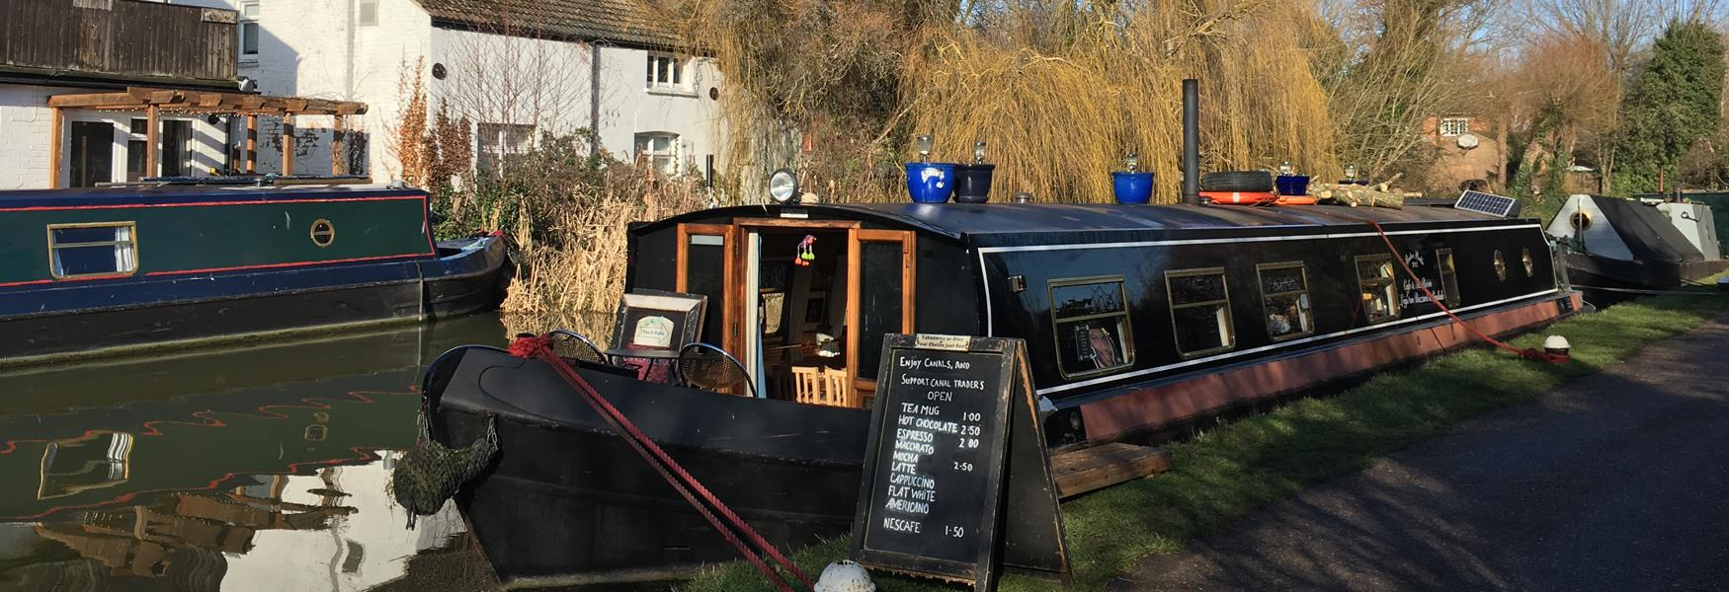

How to Apply

To apply please complete an application form which is available via the recruitment portal. Please note that CVs will not be considered.
Please provide the names and contact details of two referees.
Application Forms should be uploaded via the apply link.

Timetable
The closing date for applications is midnight on Monday 27th June
Anticipated dates for interview, potentially subject to change:
First interviews w/c 4th July. Final interviews w/c 11th July.
For an informal discussion, contact Mark Bearn at HAYS Executive on 07872 672290 or email mark.bearn@hays.com

