Whitworth Town Council
Council Offices, Civic Hall, Market Street, Whitworth, Lancs. OL12 8DP

Date as postmark

Dear ______________,

Clerk of the Council & Responsible Financial Officer vacancy

Thank you for the interest you have shown in the vacancy for the above position. Enclosed with this covering letter are the following documents:

- Application form.
- Job Description.
- Personal Specification.
- Explanatory Notes for Applicants.
- Monitoring Form, which includes an Equal Opportunities Questionnaire.

If, after reading these documents, you are interested in applying, please return your completed application form and Equal Opportunities Questionnaire as follows:

By email: info@whitworth.gov.uk

By post to: Whitworth Town Council
Council Offices
The Ashcroft (Civic Hall)
Market Street
Whitworth
Lancashire
OL12 8DP

The deadline for any applications is 12 noon on Friday 26 August 2022. Interviews will take place on Wednesday 7 September 2022.

Whitworth Town Council very much welcomes applications from anyone who shares a passion for Whitworth and who can demonstrate an understanding of the Council’s aspirations for the town.

For an informal chat about the position, the current Clerk may be contacted on Tuesday 16 August or Wednesday 24 August during the morning.

Yours sincerely,
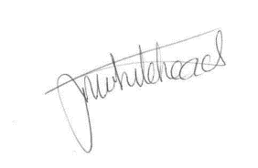
Councillor Janet Whitehead
Chair of the Council / Mayor of Whitworth

tel/fax: 01706 852018 email: info@whitworth.gov.uk www.whitworth.gov.uk

