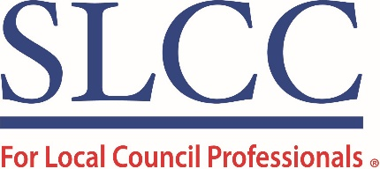
General Advisor Job Description

Job title | General Advisor
Reports to | Senior Advisor & Mentor Co-Ordinator
Hours of work | 15
Salary | £25,419 - £28,226 per annum / pro rata
Location | Mainly home working with occasional visits to the Head Office (Taunton, Somerset)

Job purpose
To provide timely and accurate advice to SLCC members, directing them to relevant advice notes and model documents in the SLCC’s online advice library. Assist in reviewing current advice notes and model documents, liaising with colleagues to ensure content is relevant, up-to-date and in line with legislation. Responsible for allocating calls and emails onto the SLCC’s team of specialist advisors, updating the CRM as appropriate. Contributing copy where necessary to The Clerk magazine.

Key Duties & Responsibilities
• Deliver excellent customer service, providing members with advice in a timely and accurate manner via telephone, email, or by live chat.
• Direct members to relevant advice notes and model documents in the SLCC’s online advice library.
• Refer members to the relevant Specialist Advisor (Employment, Finance & VAT, Planning, Environmental, Legal), or to contacts in other organisations such as Local Council Consultancy, National Association of Local Councils, Association of Local Council Clerks, One Voice Wales.
• Use the CRM to log all advice queries and monitor membership feedback, comments, and suggestions, to ensure that SLCC is in touch with the needs of its members and continuously improves how it operates and what it offers.
• Ensure that the information given to members and enquirers is consistent, robust, properly researched and up-to-date.
• Work with colleagues to provide relevant and timely content for the website and The Clerk magazine.
• Undertake continuous professional development in identified areas.
• Take on additional responsibilities commensurate with the role as required as the role develops.

Person Specification

Experience | Essential | Desirable
Proven track record of providing outstanding customer service | 
Experience of using evaluation tools
Experience of being a Clerk
Experience of being an SLCC Branch Officer / Mentor
Good understanding of local council legislation and practice
CiLCA / FiLCA qualified
Qualified to Community Governance Degree level
Ensuring positive outcomes whilst maintaining good working relationships
Skills | Essential | Desirable
Excellent verbal and written communications skills
Empathy and patience and the ability to analyse and apply appropriate judgement in recognising the key points of a quey
A flexible approach with the ability to deliver work on own initiative and under pressure
Proven organisational skills and the ability to identify and manage workload priorities

