PRESS RELEASE
Local Council Clerk Week: 10 – 14 June 2024
All over England and Wales, clerks to town, parish and community councils are working hard for their communities, serving populations ranging from a few hundred people in rural villages, several thousand in market towns and large towns and cities with more than 50,000 residents.
Local councils are not new – these first-tier local authorities were introduced in 1894 to give a democratic voice to local people. But they have changed enormously in that time, especially over the last 20 – 30 years. They are real place shapers and, today, many manage and maintain parks, sports facilities, skateparks and recreation grounds, play areas, allotments, community and youth centres, car parks, public toilets, cemeteries, street cleaning, events and much more. They’re good in a crisis too and helped coordinate local efforts during the pandemic.
So, who runs them? Working with their councillors, local council clerks get things done, often responsible for bringing everything together. From lobbying local MPs, working with unitary, district or county councils for changes to speed limits and car parking charges, reporting potholes, running the finances, applying for grants for a new play area, leading local climate change initiatives, running coronation celebrations and respectful remembrance parades or researching complex planning applications – it’s a clerk at the heart of it.
Clerks are professionals, they’re usually trained and qualified in community governance and council administration. Juggling a range of skills from finance and accounting, staff management and HR to understanding and interpreting relevant and ever-changing legislation. They’re advisers to their councillors making sure that what councils do is done properly, then they roll up their sleeves ready to lead volunteers to clean rivers, collect litter or fundraise for local projects.
Chief Executive of the Society of Local Council Clerks, Rob Smith, said: “Clerks are the lynchpins to around 10,000 local councils in England and Wales. They manage and coordinate the services that we all notice the most in our neighbourhoods. Quite simply, they make things happen by empowering their councils and serving their local communities. But, disappointingly, they’re often not properly recognised for just how much they do. I think it’s time that we celebrated the amazing work they do.”
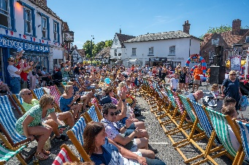
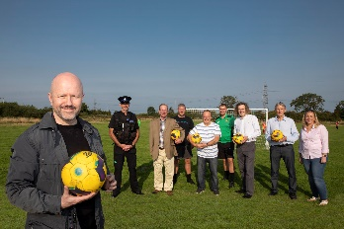
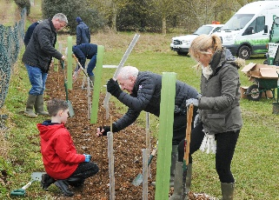
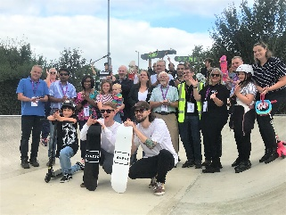
Clerks are recognised and celebrated in other countries and Local Council Clerk Week aims to help raise the profile of this important profession here and explain the importance of the work clerks do on behalf of town, parish and community councils.
Figure 1 The annual summer festival in 2022 organised by Princes Risborough Town Council
Figure 2 A project to bring football facilities back to the community of Minera, supported by David Hinchliffe, Clerk to Minera Community Council
Figure 3 A community planting event organised by Dunstable Town Council
Figure 4 Haydon Wick Parish Council redeveloped the Swindon Skate Park to create a pivotal point for youth engagement activities

For more information about Local Council Clerk Week and the work of town, parish and community clerks, please contact Gemma Rickard, Head of Marketing & Communications at gemma.rickard@slcc.co.uk

