**Radyr & Morganstown Community Council**

|  |  |
| --- | --- |
| The Old Church Rooms  Park Road  Radyr  Cardiff CF15 8DF | **RMCC Logo Colour** |

**SENIOR CLERK & RESPONSIBLE FINANCIAL OFFICER (P/T)**

**Council:** Radyr & Morganstown Community Council

**County:** Cardiff

**Salary:** NJC scale point 24 to 28 (£33,024 to £36,648) pro-rata.

Radyr & Morganstown Community Council is looking to appoint a self-motivated and well-organised individual who will be able to bring experience to the position of Senior Clerk and Responsible Financial Officer.

This is a part-time post of 23 hours per week, working primarily from our office at the Old Church Rooms (Radyr) but with some home working allowed, subject to the business needs of the Council and with some regular evening meetings. Welsh speakers welcomed but not essential.

The main duties of the post require attendance at all meetings of the Council, preparing agendas, taking minutes, dealing with all correspondence, actioning the council’s decisions, keeping parts of our website up to date and acting as the Council’s responsible financial officer maintaining all financial records. The role will also involve liaison with the council’s Consultant Accountant regarding financial matters and supervising the work of the Assistant Clerk.

Successful candidates will preferably be CilCA qualified, but consideration will be given to suitable candidates willing to study for this.

Application is by CV and covering letter.

Further details and job description are available from Mrs. J Hopkins (Assistant Clerk) email: assistantclerk@radyr.wales or on 02920 842 213.

Closing date for applications: Monday 18 March 2024.

Interviews will be held on week beginning Monday 25 March 2024.

**Cyngor Cymuned Radur a Threforgan**

|  |
| --- |
| **RMCC Logo Colour**Ystafelloedd Yr Hen Eglwys  Ffordd y Parc  Radur  Caerdydd  CF15 8DF |

**UWCH CLERC & SWYDDOG ARIANNOL CYFRIFOL (Rh/A)**

**Cyngor:** Cyngor Cymuned Radur a Threforgan

**Sir:** Caerdydd

**Cyflog:** Pwynt graddfa NJC 24 i 28 (£33,024 to £36,648) pro-rata.

Mae Cymuned Radur a Threforgan am benodi unigolyn hunanysgogol a threfnus a fydd yn gallu dod â phrofiad i'r swydd o Uwch Clerc a Swyddog Ariannol Cyfrifol.

Swydd ran amser o 23 awr yr wythnos yw hon, yn gweithio'n bennaf o'n swyddfa yn Hen Ysgoldy’r Eglwys (Radur) ond gyda pheth gweithio gartref yn cael ei ganiatáu, yn amodol ar anghenion busnes y Cyngor a gyda rhai cyfarfodydd nos rheolaidd. Croesewir siaradwyr Cymraeg ond nid yw'r gallu i siarad yr iaith yn hanfodol.

Mae prif ddyletswyddau'r swydd yn gofyn am bresenoldeb yn holl gyfarfodydd y Cyngor, paratoi’r agendâu, cymryd cofnodion, ymdrin â phob gohebiaeth, gweithredu penderfyniadau’r cyngor, cadw'r wefan yn gyfredol - a gweithredu fel swyddog ariannol cyfrifol y Cyngor tra’n cynnal yr holl gofnodion ariannol. Bydd y swydd hefyd yn cynnwys cysylltu â Chyfrifydd Ymgynghorol y cyngor ynglŷn â materion ariannol a goruchwylio gwaith y Clerc Cynorthwyol.

Yn ddelfrydol, bydd ymgeiswyr llwyddiannus yn gymwysedig i safon CiLCA (Tystysgrif mewn Gweinyddiaeth Cynghorau Lleol), ond rhoddir ystyriaeth i ymgeiswyr addas sy’n barod i astudio ar gyfer hyn.

Rhaid gwneud cais am y swydd drwy CV a llythyr atodol.

Mae manylion pellach a disgrifiad swydd ar gael gan Mrs J Hopkins (y Clerc Cynorthwyol): e-bost: assistantclerk@radyr.wales neu ar 02920 842 213.

Y dyddiad cau ar gyfer ceisiadau: Dydd Llyn 18 Mawrth 2024.

Cynhelir cyfweliadau yn ystod yr wythnos sy’n dechrau ar Dydd Llyn 25 Mawrth, 2024.

**PERSON SPECIFICATION**

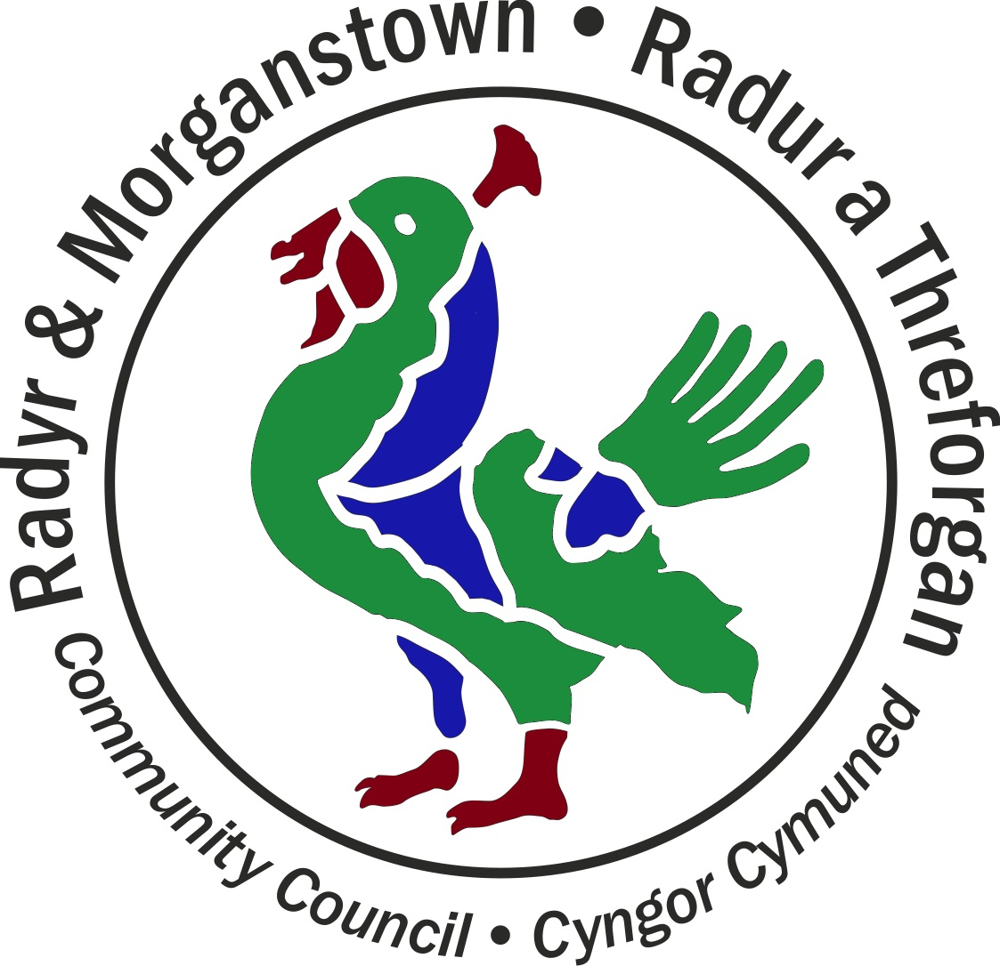

**SENIOR CLERK & RESPONSIBLE FINANCIAL OFFICER (P/T)**

|  |  |  |
| --- | --- | --- |
| **SENIOR CLERK TO THE COUNCIL/RESPONSIBLE FINANCIAL OFFICER** | | |
|  | **Essential** | **Preferred** |
| **1. Education** | Good general education: A levels or equivalent and Grade C in Maths and English GCSE or equivalent  Computer Literate | Educated to degree or HND level or equivalent professional qualification in a related subject  A recognised qualification in local government administration or willingness to study and obtain CILCA. |
| **2. Work Experience** | Experience of working on own initiative and as part of a team  Experience of using manual/computerised accounting systems and Microsoft Office suite including Excel, Word, Outlook, Publisher etc.  Broad based experience of central administration functions  Experience of supervising staff | Previous local government experience, direct experience in the town and parish council sector preferred.  Experience of agenda setting agenda, taking minutes and serving a committee  Experience of undertaking risk assessments  Financial experience including budget setting, financial monitoring and control and audit compliance |
| **3. Skills/ knowledge and aptitude** | Excellent written and oral communication skills, public speaking and presentational skills  Excellent administrative and organisational skills including ability to organise own work, meet strict deadlines, set priorities and self motivate  Excellent interpersonal skills including ability to motivate, train and develop others and foster good relationships with key partners  Good analytical, investigative and problem-solving skills  Good project management skills  Ability to contribute to the strategic development of the Council  Trustworthy with confidential information and honest | Knowledge of legal Health and Safety requirements  Knowledge of Radyr & Morganstown and the surrounding area  Website maintenance skills  The ability to speak Welsh |
| **4. Motivation** | Keen to maintain good relationships with councillors, contractors and public  Self reliant and self motivated, able to work calmly under pressure and on own initiative  Enthusiastic about & keen to work in the community and committed to community development | Willingness to undertake training and to act as the Council’s representative. |
| **5. Other** | Able to attend evening meetings and demonstrate flexibility as required. | Car driver/owner |

*It is essential that when making an application, candidates specifically address the criteria set out in the person specification. This information will be used in deciding those to be shortlisted.*

**JOB DESCRIPTION**

**SENIOR CLERK & RESPONSIBLE FINANCIAL OFFICER (P/T)**

**Hours per week:** 23 hours

**Salary:** NJC scale point 24 to 28

**Annual leave:** 33 days including bank holidays, pro rata

**Reporting to:** Full Council through the Chair of Council

**Duties: Governance**

* Ensuring that statutory and other provisions governing or affecting the running of the Community Council and its activities are observed.
* Acting as the Responsible Financial Officer for the Community Council and implementing the system of financial controls as required by the RMCC Financial Regulations.
* Implementing a system of financial reporting, supported by an external accountant.
* Ensuring that the Community Council meets the statutory requirements for internal and external audit and the submission of the Annual Return.
* Ensuring that the Community Council’s obligations for risk assessment are properly met and appropriate insurance is in place.

**Duties: Council Meetings**

* Preparing agendas for Full Council, Finance Committee, Planning Committee, Publicity & Communications Committee and Employment & Allowances Committee, in consultation with the relevant Chair; attending meetings as the official clerk with responsibility for the Minutes.
* Attending Environment & Regeneration Committee meetings and providing support to the Assistant Clerk if required on Environment & Regeneration Committee matters.
* Advising the Chair on the RMCC Standing Orders and management of meetings.
* Ensuring that the Draft Minutes of Council meetings are made available to Members, usually within one week of the meeting and a Meeting Summary is published within seven working days of the meeting.

**Duties: Financial Management**

* Ensuring that all Council spending, including spending on the Old Church Rooms, follows the requirements of the RMCC Financial Regulations.
* Maintaining the official Order Book, including a record of the required approvals for spending.
* Verifying all invoices received are correct and certifying the monthly payment schedule prior to approval by the Chair of Finance Committee.
* Confirming payroll payments with the external accountant, prior to approval by the Chair of Finance Committee
* Submitting monthly returns to the Cardiff and VOG Pension Fund in relation to staff pensions.
* Managing major contracts for goods and services provided to the Council, including liaising with the Assistant Clerk in relation to contracts for the Old Church Rooms.

**Duties: Council policies and decisions**

* Monitoring the implemented policies of the Community Council to ensure they are achieving the desired result and suggesting modifications where appropriate.
* Implementing the decisions made at Full Council meetings, including sending official correspondence on behalf of Council.
* Acting as the representative of the Community Council when required and as directed by the Chair of Council.

**Duties: Council staff**

* Acting as line manager for all other Council staff, including carrying out annual appraisals and reporting to Employment & Allowances Committee.

**Duties: Other**

* Receiving correspondence and documents on behalf of the Community Council; dealing with correspondence or documents, including bringing such items to the attention of the Community Council as appropriate.
* Maintaining all statutory information on the RMCC website.
* Liaising with Members of Publicity & Communications Committee on press releases and other material about the activities, policies and decisions of the Community Council
* Liaising with Cardiff Council, Welsh Government, One Voice Wales as necessary.
* Supporting the Assistant Clerk in the day-to-day running of the Old Church Rooms as and when required.
* Attending training courses, seminars, etc. as required by the Community Council, within working hours.
* Any other reasonable tasks commensurate with the nature of the role.